The Acorn Restaurant
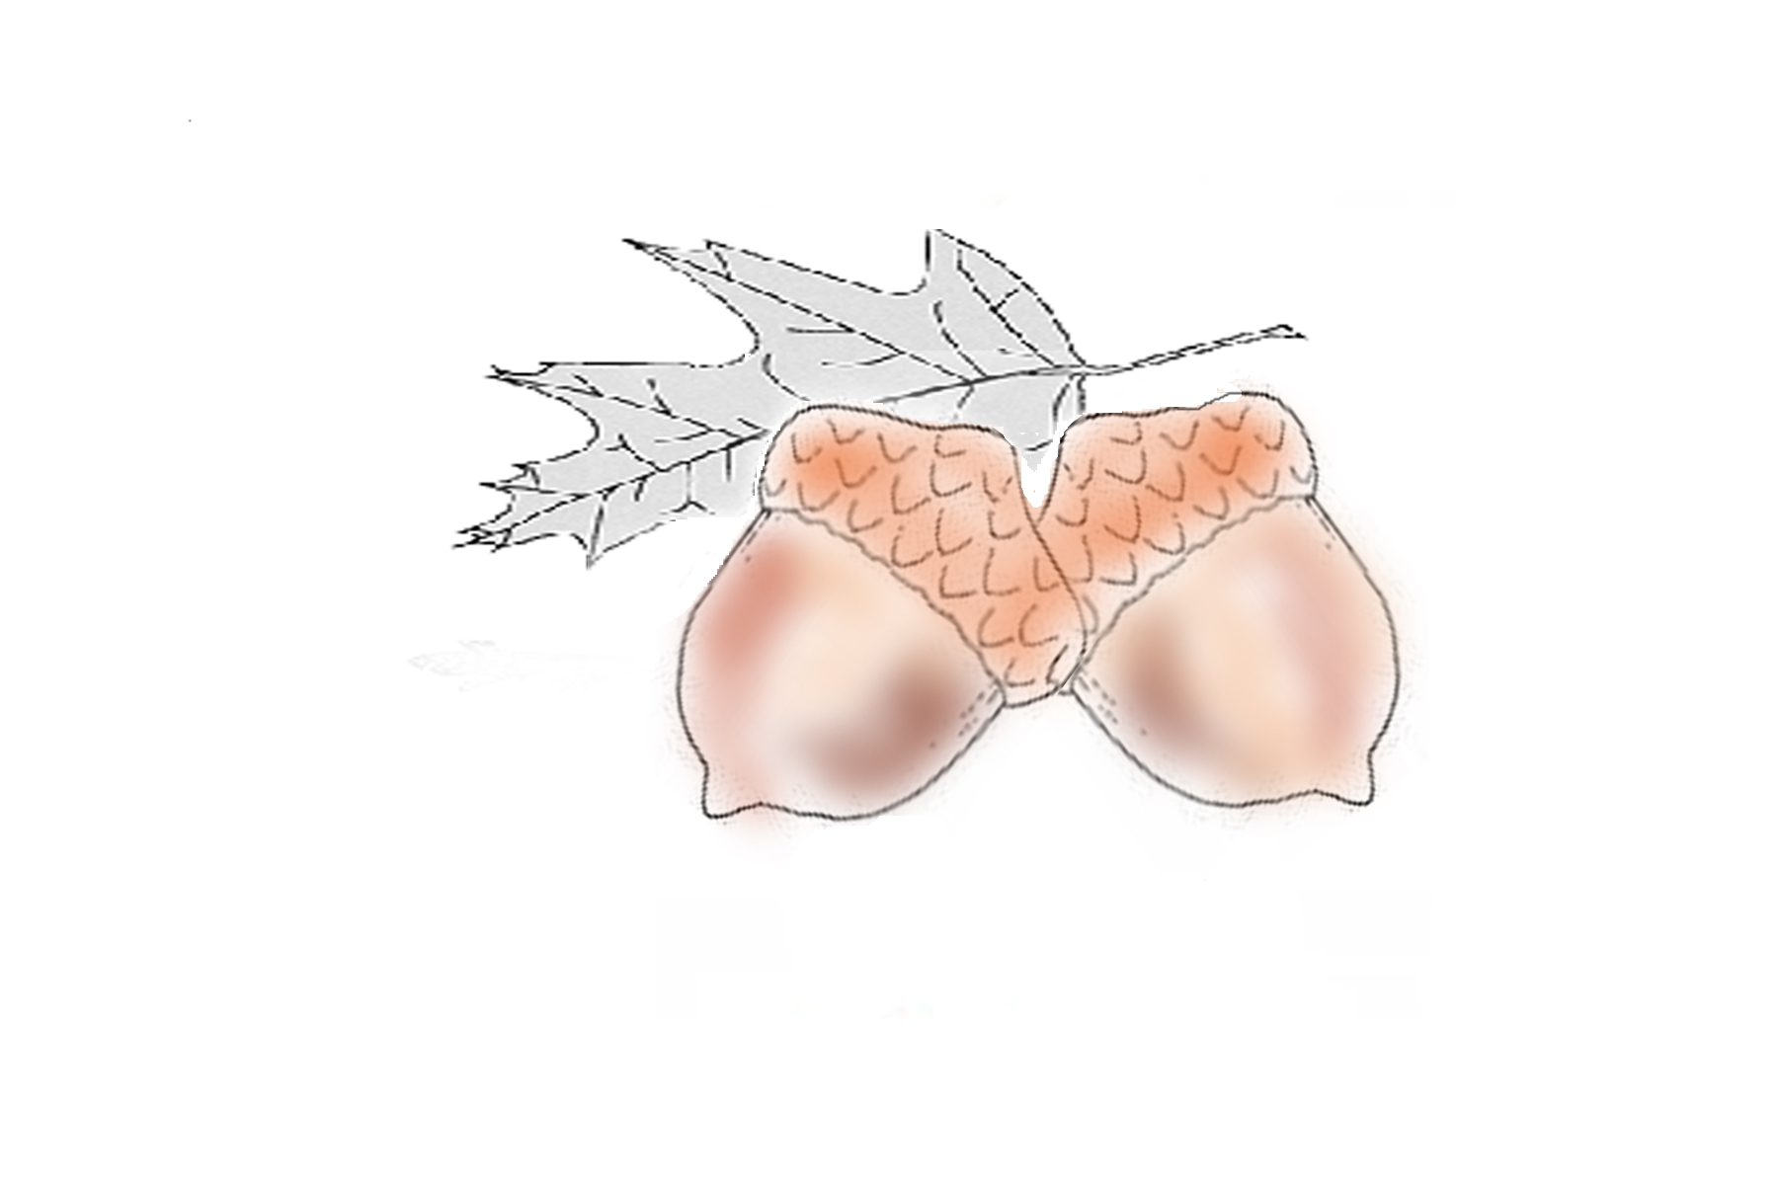
410 North Louisville Street,
Harlem, GA
706-556-8222

Welcome to The Acorn, where every Sunday is family day. We proudly serve our Sunday dinner family style. Choose two meats and three vegetables for your table and we will bring it out on platters. Drinks, rolls and desserts are included. If you need more, just ask!!

Today’s Menu:

Entrees (choose two)
Mushroom Chicken Pork Tenderloin
Sliced Ham Chicken Cakes
Ribeye

Side Items (choose three)
Garden Salad Squash Casserole
Wild Rice Turnip Greens
Mashed Potatoes Corn
Acorn Cakes
Dessert
Pecan Pie Surprise Pie
Peanut Butter Mousse Vanilla Ice Cream
Cream Cheese Pound Cake Irish Apple Cake
Children under ten (10) will be served Ice Cream.

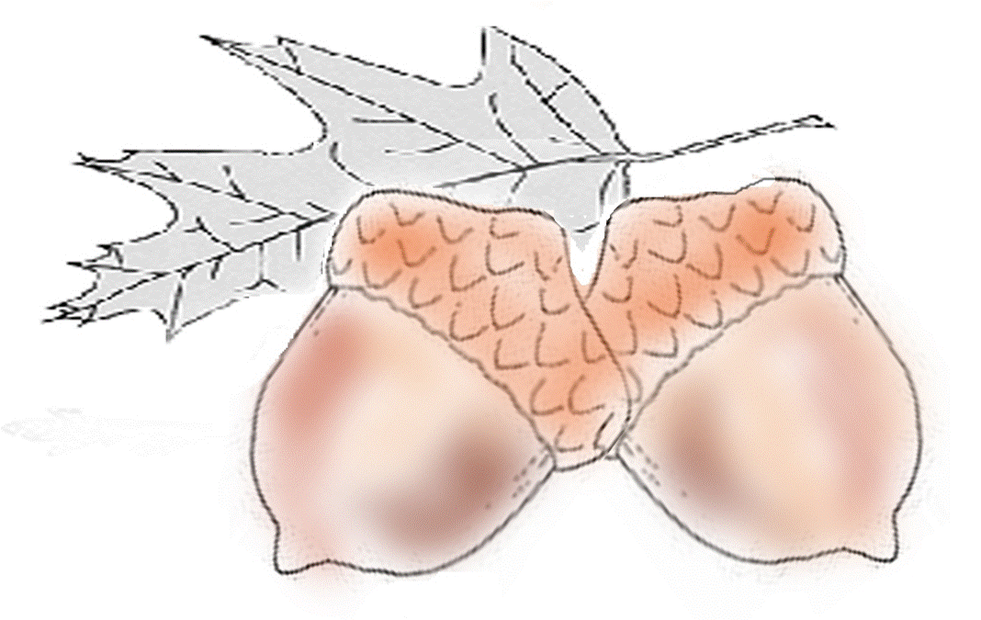
The Acorn Restaurant
410 North Louisville Street,
Harlem, GA
706-556-8222

Welcome to The Acorn, where every Sunday is family day. We proudly serve our Sunday dinner family style. Choose two meats and three vegetables for your table and we will bring it out on platters. Drinks, rolls and desserts are included. If you need more, just ask!!

Today’s Menu:

Entrees (choose two)
Mushroom Chicken Pork Tenderloin
Sliced Ham Chicken Cakes
Ribeye

Side Items (choose three)
Garden Salad Squash Casserole
Wild Rice Turnip Greens
Mashed Potatoes Corn
Acorn Cakes
Dessert
Pecan Pie Surprise Pie
Peanut Butter Mousse Vanilla Ice Cream
Cream Cheese Pound Cake Irish Apple Cake
Children under ten (10) will be served Ice Cream.

